**Final Project**



NAME: Roll No.

SAYYAM SHAHID L1F20BSCS0010

Muhammad Aliyan L1F20BSCS0029

Hammad Qayyum L1F20BSCS0025

Subhan Asif L1F20BSCS0001

SECTION: C6

SUBJECT: Object Oriented Programming

**INTRODUCTION**

**What is Library Management Software?**

Library management software, uses to organize all physical and digital assets. Library management solutions act as the central hub for all library-related tasks. Library management solutions allow libraries to become more effective and efficient, as well as drive member engagement. Library management software has brought libraries into the 21st century, enabling their digital transformation and making them more accessible to the digital-native generation.

Key Benefits of Library Management Software

• Increase member engagement

• Improve library efficiency

• Easier cataloging

**Why Use Library Management Software?**

**Improve Organization** — Libraries thrive as proper organization, and library management software is all about improving organization within the library. Library management solutions drive the improved management of every facet of the library, including circulation and membership. Libraries can leverage the capabilities of a library management system to organize their book database.

**Increase Efficiency** — One of the main reasons to use library management software is the increase in efficiency that these systems provide. Libraries are all about keen organization, and having a centralized repository that contains detailed asset information is an excellent way to improve that organization.

**Increase Engagement** — The opportunity to increase member engagement is one of the most useful benefits of modern-day library management solutions. Library management solutions typically contain portals, through which librarian can access all of their membership activity and book information.

**Features**

* We can add a book in our database
* We can find our book in our database
* It adds members of faculty and students
* It verifies members from the database
* It issues book to members(faculty, students)
* It updates the status whether book is issued or returned
* It displays the status of the books

**Concepts used in the program**

Concepts we have used while making the project and trying to fulfill all the concepts of oop:

* Classes
* File Handling
* Inheritance
* Polymorphism
* Abstract classes/Virtual Function
* Association
* Composition
* Abstraction
* Encapsulation
* Diamond Design Problem

**UML**

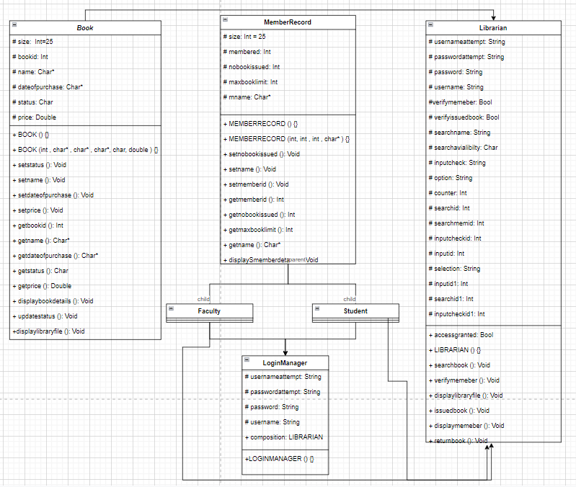

**Classes:**

* Book (**Abstract)**
* Student (**Concrete)**
* Faculty (**Concrete)**
* Login Manager (**Concrete)**
* Member Record (**Concrete)**
* Librarian (**Concrete)**

**Console Screen Starting**

